297 Hartford Pike

Shrewsbury, MA

800.341.6702

508.798.3411

309 Sheep Davis Rd

Concord, NH

800.341.6702

603.225.1171

901 Center St

Auburn, ME

800.341.6702

207.784.9311

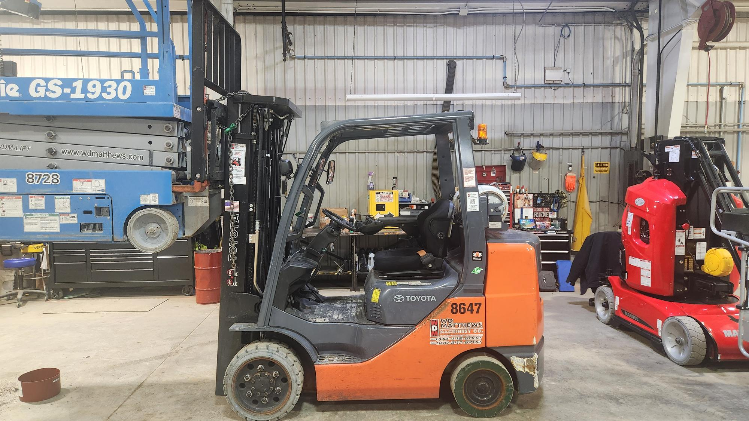

|  |  |  |  |
| --- | --- | --- | --- |
| **Unit** |  |  | **R8647** |
| **Year** |  |  | **2017** |
| **Manufacturer** |  |  | **TOYOTA** |
| **Model** |  |  | **8FGCU32** |
| **Base capacity** |  |  | **6,500** |
| **Power** |  |  | **L/P** |
| **Mast** |  |  | **187" FSV MAST** |
| **Hours** |  |  | **6100** |
| **Features** |  |  | **Side Shifter** |
|  |  |  | **Cushion Tires** |
|  |  |  | **48” Forks, MINI LEVER W/ ERGO-SHIFT** |
| **Warranty** |  |  | **30 Day 100%** |
| **Price** |  |  | **$24,900.00 Rental ready** |
|  |  |  |  |
|  |  |  |  |
|  |  |  |  |